**V8  Phase 1. 2024 Monthly High, Low, and Round Number Indicator**

**History**

* The 2024 Monthly High Low and round number indicator is a simplified revision of an earlier more complex 2017 comprehensive support and resistance indicator.

**Purpose**

This is a phase one support and resistance (S-R) indicator used for swing trading Forex pairs and at a later date the S&P 500

It’s functional purpose of this phase one indicator is to:

* Identify all monthly highs, lows, and round numbers over a user-determined period of time (up to one year ) and then display these price points by horizontal lines on NT8 price charts.
* Users also have the option to create a rectangle around horizontal lines, to create S-R zones. (see below for description and illustrations)
* These S-R lines will be used along with OB-OS indicators and other price action methods used to determine a potential trend change and  followed by a potential advantageous trade entry point.
* This a phase 1 indicator will require a simplified version of three elements:
  + 1. **A.**  **Data Repository:** Will store monthly highs and lows and round numbers
  + 2. **A User Interface:** Will control how S-R lines and rectangle zones appear to the user on an NT8 price chart
  + 3**. An NT8 Price Chart** the price chartwill visually show horizontal S-R lines and rectangle zones-horizontal lines will go left to right from end to end across the price chart.  Depending on the user's preference S-R lines may begin at different dates for a cleaner less cluttered look.
  + NT8 price chart will have a button at the top right of the MTA price screen that will be labeled S- R lines (see visual)

* **The data repository**
  + The indicator requires a data repository to locate and store the monthly, highs, lows, in addition to round numbers.
  + Initially it will store 1 year (starting 4-1-23) of monthly Highs-Lows  and round numbers.
  + In addition each month it will add new highs and lows, as well as monthly round numbers automatically so the data grows over time.
* **The user interface** will extract historical  data from the repository and create horizontal lines on the price chart which will indicate the monthly, highs and lows and round numbers. These horizontal lines indicate the monthly support and resistance levels as well as round numbers.
* The user interface will also include multiple window based user interface windows. (See page 6 figure one, two, three) These act as user controls and will include a variety of options for displaying S-R and round numbers see page7)
* The user interface will quantify how many times the price has hit certain highs, lows, and round numbers over a period of times designated by the user.
  + This will show up in a specified way on the price chart as well as the data repository.
* See page ________ for the data, repository illustration.
* The user interface also allows the user control over how text messaging appears on the price chart as well as numerous methods of decluttering and simplifying the visual appearance of the various lines and rectangles on the price chart.
  + This count will be shown for the date range the indicator is set for

**Next Steps:**

* Begin developing the data repository to store the required price data.
* Design the user interface to display the horizontal lines on the chart.
* Build logic to quantify the number of times each level has been hit.
* Historical data Is retrieved and stored beginning April 1, 2023 and will continue to be retrieved and stored automatically at the end of each month.

A developer will need the following skills and experience:

* NinjaTrader 8 Indicator and Script Development.
* Data Repository Development and Integration.
* NinjaTrader 8 Custom and Window Development.

**User Interface Window & Data Repository Table Specifications**

* **Column Headers (titles):** Refer to Table 1 - Data Repository Table for details
* Cell Data Types
* **Row Number:** Integer - 3 digits
* **Show/Hide:** Binary
* **Price:** Floating Point Number with 4 significant digits before and 4 significant digits after the decimal point (NNNN.NNNN)
* **Date:** MM/DD/YYYY
* **Monthly High, Low or Round Number:** "MH", "ML" or "MRN"
* **Price Hit Count:** Integer - 2 digit
* **Grouped Prices:** Binary
* **Cluster Line Count:** Integer - 2 digits
* **Cluster Pip Range:** Integer - 2 digits
* **Cluster Weighing:** Integer - 2 digits
* **Cluster Consol. Line Thickness:** Integer - 1 digit
* **Cluster Consolidated Line Color:** "Black", "Red", "Blue", "Green", "Purple" or "Orange"
* **Zone Weighing:** Integer - 2 digits

A user interface window (Figure 1 - User Interface Window) shall be created to provide a visual representation of the data in the data repository and support user interaction with the data. This User Interface window shall support the following functionality:

1. The user shall have the ability to assign a unique cluster pip range per cluster, which shall override the "Cluster Global Pip Range" assigned in the Properties and the User Interface.
   1. The default value of the pip range per cluster for all clusters shall be equal to the value of the "Cluster Global Pip Range".
   2. The unique pip range per cluster shall be assigned by the user in the corresponding editable field in column 9 **(See Figure 1 - User Interface window - Callout I).**
      1. When a cell is edited in the user interface, the content shall be updated in the corresponding cell in the data repository.
      2. Changes to Cluster Pip Range values shall be saved by pressing the "Save" button.
   3. When the pip range of a cluster is changed:
      1. The cluster shall be updated to add or remove prices as needed per the new pip range.
      2. The Grouped Prices and Cluster Line Count columns shall be updated to reflect the cluster changes.
      3. The background color of rows shall be updated to reflect changes in the prices (rows) included in the cluster.
      4. Changes to the Cluster Consolidated Prices value shall be reflected in the price chart.

**Figure 1 - User Interface Window**

|  |  |  |  |  |  |  |  |  |  |  |  |  |
| --- | --- | --- | --- | --- | --- | --- | --- | --- | --- | --- | --- | --- |
| 1 | 2 | 3 | 4 | 5 | 6 | 7 | 8 | 9 | 10 | 11 | 12 | 13 |
| **Row Number       A** | **Show/Hide   B** | **Price         C** | **Date     D** | **Monthly High, Low and Round Number E** | **Price Hit Count   F** | **Grouped prices     G** | **Cluster**  **Line**  **Count H** | **Cluster Pip Range I** | **Cluster**  **Weighing J** | **Cluster Consol. Line Thickness K** | **Cluster Consol. Line Color    L** | **Zone Weighing M** |
|  | □ | 1.2107 | 1/1/2015 | MH | 1 |  |  |  |  |  |  |  |
|  | □ | 1.2107 | 1/1/2015 | MH | 1 |  |  |  |  |  |  |  |
|  | □ | 1.2103 | 1/1/2015 | DL | 1 |  |  |  |  |  |  |  |
|  | □ | 1.2069 | 1/2/2015 | DH | 1 |  |  |  |  |  |  |  |
|  | □ | 1.2034 | 1/1/2015 | DL | 1 |  |  |  |  |  |  |  |
|  | □ | 1.2000 | 1/2/2015 | DC | 1 |  |  |  |  |  |  |  |
|  | □ | 1.2000 | 1/2/2015 | DL | 1 |  |  |  |  |  |  |  |
|  | □ | 1.2000 | 1/2/2015 | WC | 1 |  |  |  |  |  |  |  |
|  | □ | 1.1976 | 1/4/2015 | DH | 1 |  |  |  |  |  |  |  |
|  | □ | 1.1976 | 1/4/2015 | WH | 1 |  |  |  |  |  |  |  |
|  | □ | 1.1954 | 1/6/2015 | DH | 1 |  |  |  |  |  |  |  |
|  | □ | 1.1932 | 1/5/2015 | DC | 1 |  |  |  |  |  |  |  |
|  | □ | 1.1895 | 1/7/2015 | DH | 1 |  |  |  |  |  |  |  |
|  | □ | 1.1889 | 1/6/2015 | DC | 1 |  |  |  |  |  |  |  |

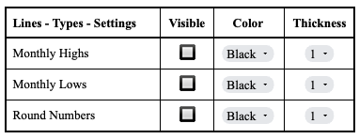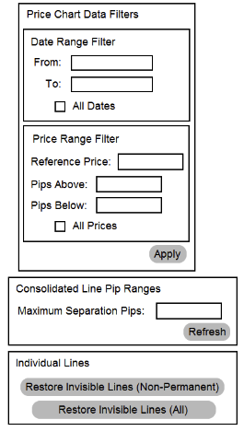

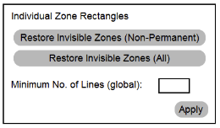

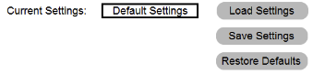

**Figure 2 - Main User Interface Page 1**

**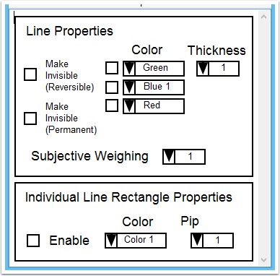           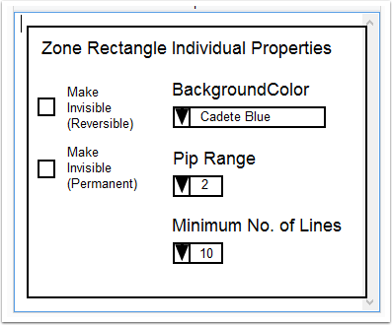**

**Figure 4 - Zone Rectangle Individual**

**Properties User Interface**

**Figure 3 - Line and Individual Line**

**Rectangle Properties User Interface**